**Summit Station Weekly Science Report**

**Reporting Period:**  January 21– January 27, 2019

**Completed by:** Gus Allen, Troy Nave

**Comments:** Techs have been preparing for turnover with the spring crew next week. High winds on Tuesday temporarily prevented checks on some outlying and roof-mounted instruments. The wind and associated blowing snow also caused a few minor malfunctions, detailed below.

Wind speeds at Summit ranged from 0.0 m/s, recorded on 2019-01-27, to 21.1 m/s on 2019-01-22. The average wind speed for the week was 8.24 m/s. Temperatures ranged from a low of -55.09˚C on 2019-01-21 to a high of -26.14˚C on 2019-01-27. The average temperature was -39.87˚C.

Summit experienced low winds intermittently from 00:09 to 04:21 on 2019-01-21, and intermittently from 13:01 to 19:24 on 2019-01-27. North winds occurred intermittently from 00:44 to 23:25 on 2019-01-21, intermittently from 00:21 to 02:05 on 2019-01-22, and intermittently from 14:55 to 23:37 on 2019-01-27 last week.

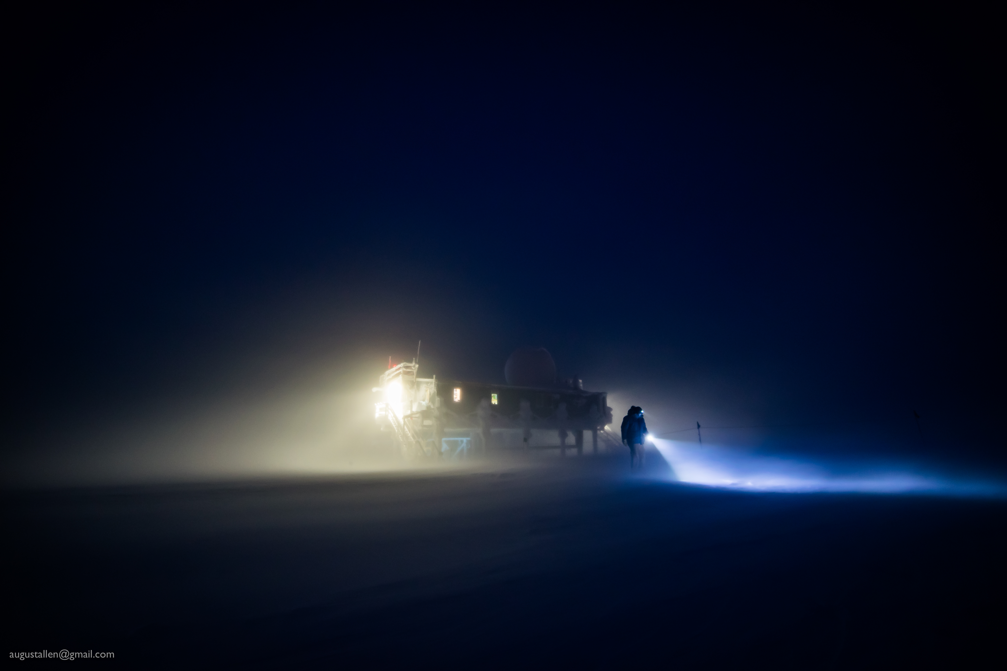

Winds gusting into the 40’s and heavy blowing snow on 1-23, making travel between buildings a dramatic experience.

**Please visit the clean air log at ftp://isr.sri.com/pub/summit/ftp/science/clean_air_traffic/**

|  |  |
| --- | --- |
| **Facilities** | **Comment** |
| TAWO | H2 generator needs part; H2 being supplied by cylinder.. |
| MSF | MMCR level 0.11 pitch 0.00 roll |
| Green House |  |
| **Experiment** | **Notes** |
| NOAA CCGG flasks | Comment:  Date performed: 2019-1-24 |
| NOAA HATS flasks | Comment: twice per month  Date performed: 2019-1-24 |
| NOAA Surface Ozone | Comment: Calibrated on 2019-1-22.  % of time operating: 100% |
| NOAA Aethelometer | Comment: Instrument offsite for service.  % of time operating: 0% |
| NOAA Meteorology | Comment:  % of time operating: 100% |
| NOAA CLAP & Neph | Comment: Span check occurred on 2019-01-22  % of time operating: 100% |
| Radionuclide Filter | Comment: Changed every other day  % of time operating: 100% |
| Aerosol DRUM Sampler | Comment:  % of time operating: 100% |
| Bamboo Forest | Comment:  Date performed: 2019-1-26 |
| SnowFox | Comment:  Date performed: 2019-1-24 |
| ICESat Accumulation | Comment:  Date performed: 2019-1-16 |
| GFZ Potsdam Seismometer | Comment:  % of time operating: 100% |
| DTU Magnetometer | Comment:  % of time operating: 100% |
| UNAVCO | Comment: |
| Helmig CUGC | Comment: Using cylinders for H2 supply.  % of time operating: 100% |
| Steffen Tower Instruments | Comment:  % of time operating: 100% |
| Steffen Solar Instruments | Comment:  % of time operating: 100% |
| ICECAPS-ACE Total Sky Imager | Comment: Offline for the winter.  % of time operating: 0% |
| ICECAPS-ACE Radiosonde | Comment: 2019-01-22 1115Z launch cancelled due to poor conditions.  Dates performed: Twice daily. |
| ICECAPS-ACE MWR | Comment: On 1-24, the HATPRO radiometer had a communication error requiring a hardware restart.  % of time operating: 95% |
| ICECAPS-ACE SODAR | Comment: Significant snow accumulation in dishes during high wind event, cleaned 1-24  % of time operating: 98% |
| ICECAPS-ACE POSS | Comment:  % of time operating: 100% |
| ICECAPS-ACE MASC | Comment: Instrument offsite for service; expected return 2019-06.  % of time operating: 0% |
| ICECAPS-ACE MMCR | Comment:  % of time operating: 100% |
| ICECAPS-ACE CAPABL | Comment: On 1-26, the CAPABL PC was found showing “Disk Boot Error”. The PC was rebooted and normal operations were restarted. On 1-27, CAPABL was found not lasing. This issue was resolved remotely after notification.  % of time operating: ~95% |
| ICECAPS-ACE MPL | Comment:  % of time operating: 100% |
| ICECAPS-ACE Ceilometer | Comment: Instrument enclosure accumulated snow and ice during wind event on 1-22 and 1-23, partially obscuring the window and generating errors in the software. I was able to manually remove much of the snow on 1-24, and the remainder sublimated out over the next few days.  % of time operating: 100% |
| ICECAPS-ACE PAERI | Comment:  % of time operating: 100% |
| ICECAPS-ACE IcePIC | Comment: No images captured this week  Date(s) performed: |
| ICECAPS-ACE CLASP | Comment: Instrument offsite for service; expected return 2019-02.  % of time operating: 0% |
| ICECAPS-ACE CPC | Comment: Instrument offsite for service; expected return 2019-02.  % of time operating: 0% |
| ICECAPS-ACE OPC | Comment: Instrument is operational and collecting data, but files are not presently being transferred via DATAMAN.  % of time operating: 100% |
|  |  |  |
|  |  |  |